Finalised project review

Files and webpages
The project requires 3 working webpages that are linked together creating a website format.
This project has 3 main working webpages that are linked together and 2 other webpages that serve a purpose and are not required for marking.
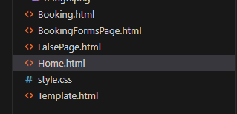
FalsePage.HTML is purely a webpage that has been linked to elements that can be clicked by the user but will display a message guiding the user to the webpages that are active for the project.
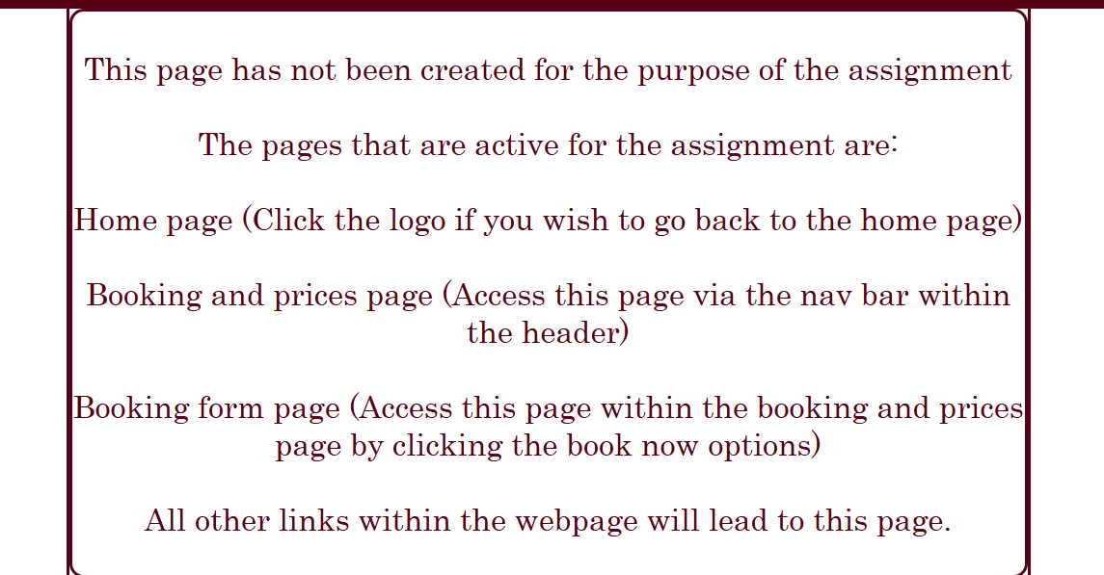
The HTML code within the webpage may vary from the finalised code within the main webpages as this was created before finalising the other webpages.

Template page was created as an initial setup for the webpages. The footer and header were implemented along with some other content within other webpages. This ensured that once these elements were created, I did not have to create them again for each webpage. Simply copying the template and saving it as the intended webpage before adding additional content.
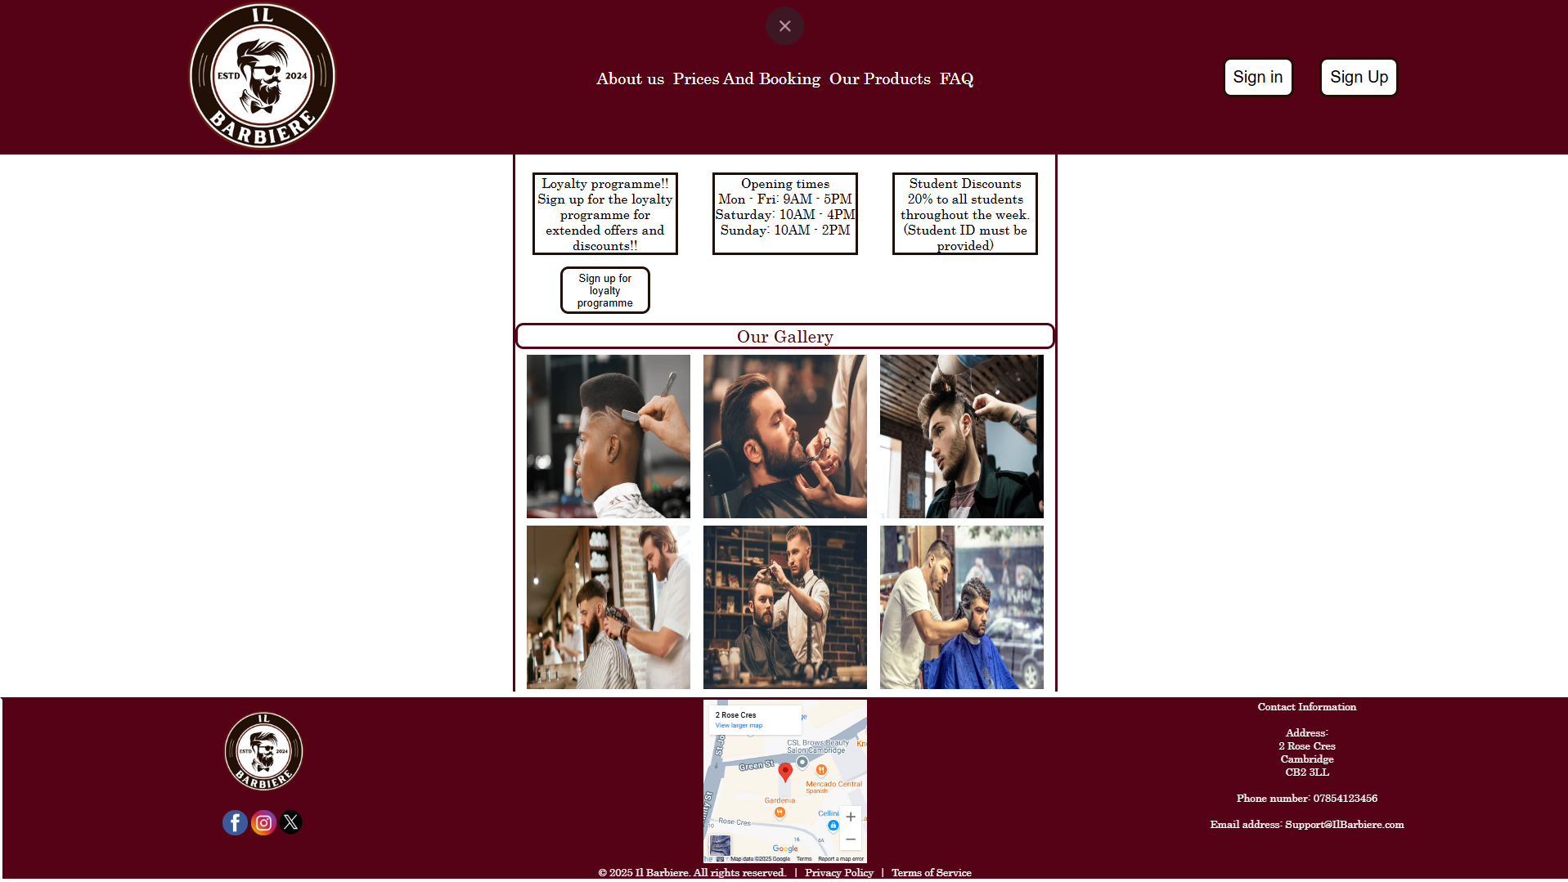
The gallery section was supposed to be used across all webpages but this was changed later due to the user experience being unpleasant with the layout of the page. The gallery would have caused the user to scroll down each time they were on a webpage to find the elements solely for that webpage. Some elements may have changed to create a better finalised product for the intended webpages.

Home page has all the content from the template with the addition of articles. The articles are intended for the user to be able to view current trends within the fashion industry, each article has a link to an intended webpage that has been referenced within the HTML section.
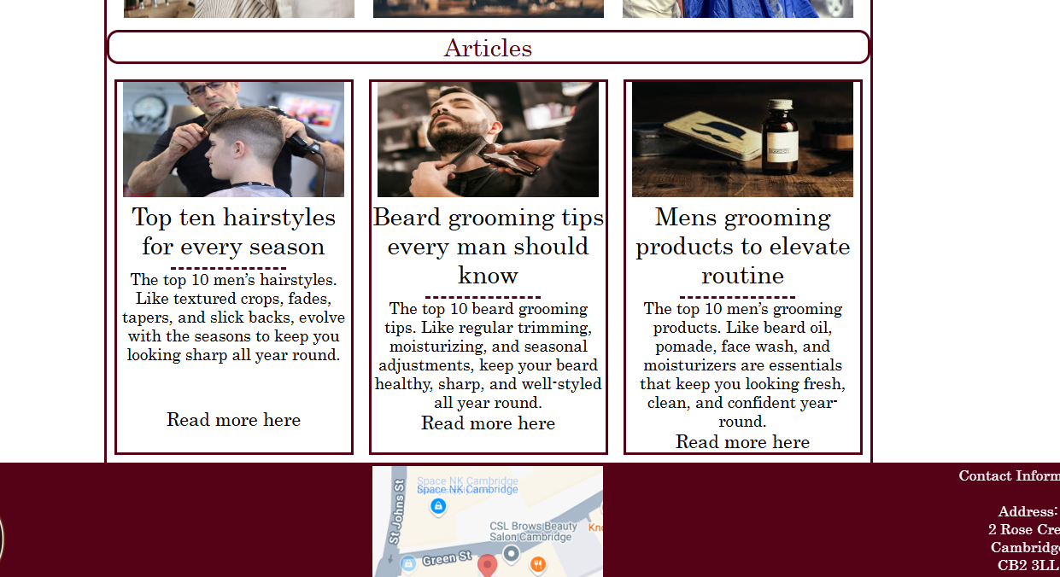

Booking and prices page is accessed through the corresponding link within the header’s navigation bar.
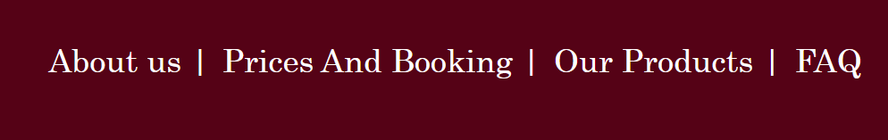
Once on this webpage their will be 2 options to pick from. Both options have a list of services that would be included within the option and a price to correspond to that service. A button to book not would lead to the last page for the website assignment. The section is clearly marked using a head as ‘Haircut options’ and student discount is displayed clearly for the websites target audience.
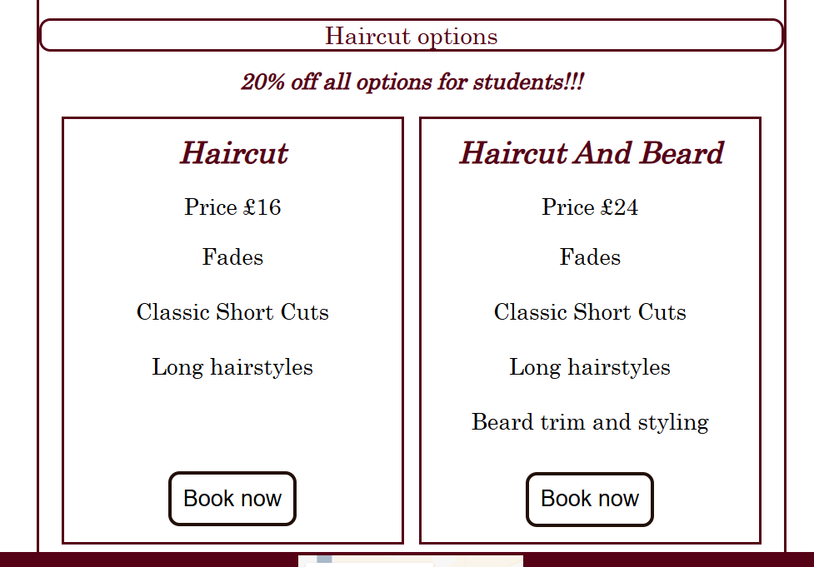

The booking form to fill out for the user when booking an appointment. To get to this page the book now button from the previous page must be selected from one of the options. The form is quick and easy to fill out with the date and time have selection boxes added to them to make it easier.
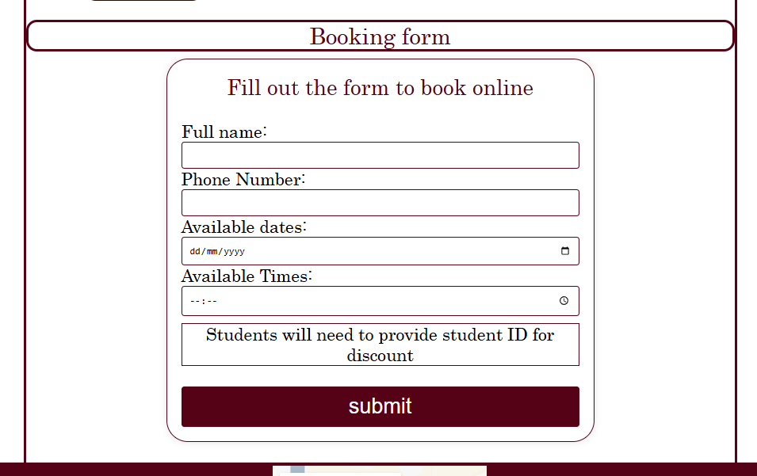
Date and time boxes for user experience.
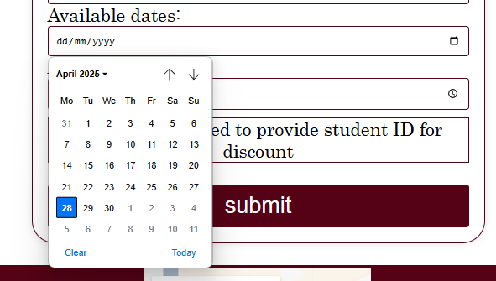
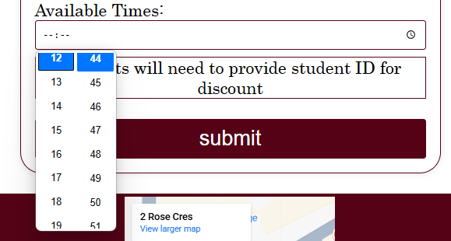

A few extra things that have been added for the website that has not been covered is the integrated map with a pin on the location of the barbers shop. The pin is located within the area of Cambridge for aesthetics of the assignment.
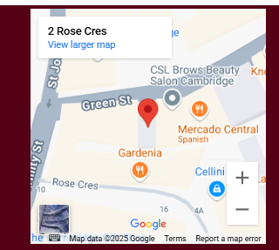

The logo within the header is a link to the home page, this is common within websites in the current day so this complies with user experience.
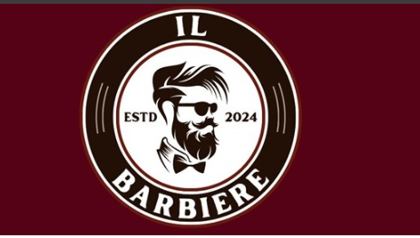
Social media links are used within the footer, social media is huge and websites incorporate these so that the user can find their corresponding pages quickly. The social media links for my webpages are pictures of the corresponding social media however the links only lead to the homepage of the corresponding sites as this is for academic use and have not created the social media pages for this project.


